1. SMARTS Public Access (click ***View SW Data*** button)

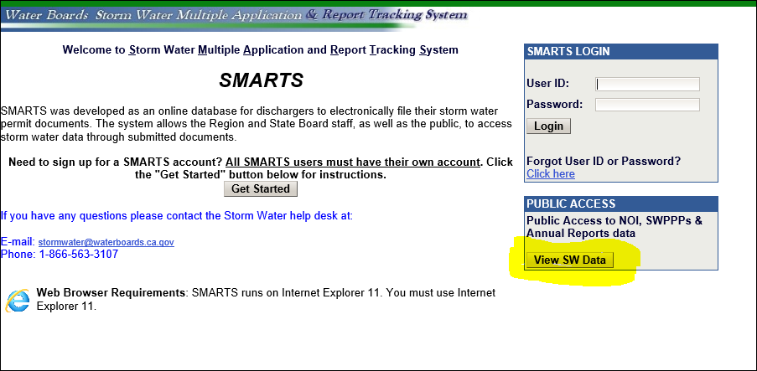

1. Select ***Download NOI Data By Regional Board***

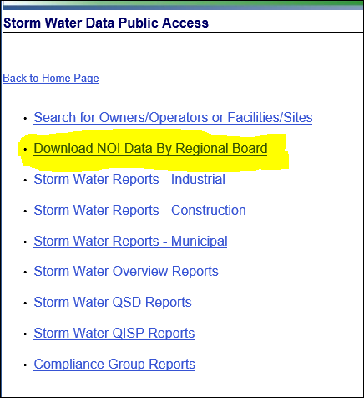

1. Select ***State Board*** in the dropdown menu

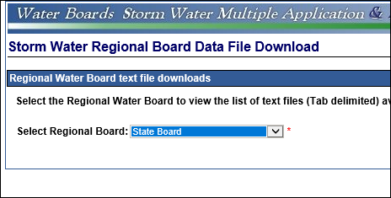

1. Select ***Industrial Ad Hoc Reports – Parameter Data*** for the monitoring data, and ***Industrial Application Specific Data*** for the facility information

